PROJECT REPORT OF CO-OP Project at Industry (Module-2)
ON

AI-Powered Credit Scoring and Document OCR System for Loan Risk Assessment
submitted in partial fulfilment of the requirements for the award of degree of

BACHELOR OF ENGINEERING
In
COMPUTER SCIENCE AND ENGINEERING

Submitted by Supervised By:
Om Tomar (2210994882) Lalit Sharma
Sahajpal Singh (2210994831) Department of Computer Science and Engineering
Ridhima Chopra (2210994826) Chitkara University Institute of Engineering and Technology
Ishpreet Kaur (2210990424) Chitkara University, Punjab, India


DEPARTMENT OF COMPUTER SCIENCE AND ENGINEERING

CHITKARA UNIVERSITY INSTITUTE OF ENGINEERING AND TECHNOLOGY
CHITKARA UNIVERSITY, PUNJAB, INDIA

CONTENTS

S.No. | Title | Page No.
1 | Abstract | 3
2 | Introduction | 4
3 | Methodology | 5
4 | Tools and Technologies | 6
5 | Implementation | 7
6 | Major Findings/Outcomes/Results | 8
7 | Conclusion and Future Scope | 16
8 | References | 17
9 | Appendices | 18

DECLARATION
We hereby certify that the work presented in the project report entitled "AI-Powered Credit Scoring and Document OCR System for Loan Risk Assessment" in partial fulfilment of requirement for the award of the degree of Bachelor of Engineering (Computer Science and Engineering) submitted in the department of Computer Science and Engineering at Chitkara University Institute of Engineering and Technology, Chitkara University, Punjab, India, is an authentic record of our project work carried out under the supervision of Lalit Sharma. The matter presented in this report has not been submitted elsewhere for the award of any degree. The project is prepared for copyright-oriented submission and academic evaluation.

Place: Rajpura Om Tomar, 2210994882
Date: 30 April 2026 Sahajpal Singh, 2210994831
Ridhima, 2210994826
Ishpreet Kaur, 2210990424

Lalit Sharma
Assistant Professor
Department of Computer Science and Engineering
Chitkara University Institute of Engineering and Technology,
Chitkara University, Punjab, India

ACKNOWLEDGEMENT

We express our sincere gratitude to our mentor Lalit Sharma and the Department of Computer Science and Engineering, Chitkara University, for guidance and evaluation support. We also acknowledge the public datasets, open-source libraries, and research references that enabled this reproducible implementation.

ABSTRACT
Analyzing applicant profile information and documentation received during onboarding is critical to understanding if an applicant is low-risk enough to receive a loan. This project utilizes an artificial intelligence (AI) based credit scoring system combined with an optical character recognition (OCR) system that will allow for automated benchmark testing of credit scoring methods as well as document recognition for performing loan-risk assessment on applicants. The credit-scoring component will evaluate machine-learning and neural-network models using the German Credit data set and LendingClub sample transactions; while the document-intelligence component will use real data with PaddleOCR to create an evaluation pipeline to process the public scanned-document datasets of the ICDAR-2019 SROIE and FUNSD test datasets prior to borrower document processing.

The completed benchmark establishes four model types (Logistic Regression, Random Forest, Gradient Boosting, Multi-Layer Perceptron) to receive performance metrics (ROC, PR, recall, F1-score, overall accuracy, confusion- matrix, feature-importance) using AUC metrics; the highest performing pilot in the German Credit sample had a ROC AUC of 0.831, the highest performed pilot in the LendingClub sample had a ROC AUC of 0.722; the OCR portion of the project will utilize the service metrics obtained from the evaluation artifacts created by processing the ICDAR-2019 SROIE and FUNSD document samples into PaddleOCR format for evaluation purposes as the basis for reporting OCR performance..

INTRODUCTION

In banking and financial technology, credit scoring is a key decision support method. Traditional approaches rely primarily on rules that are straightforward to audit; these traditional approaches may not account for complex, non-linear relationships about risk. Newer machine learning techniques can provide better prediction accuracy, but these techniques need to be transparent, traceable, and repeatable so that lending practices can be conducted responsibly.

This project compares a tabular credit risk benchmark against an OCR extension because true loan processes require both structured applicant information and submitted documents. The final product is packaged for submission at GitHub; the code, data, experimental files, report, PowerPoint and IPR will all be ready to submit.

Objective | Description
O1 | Construct a repeatable benchmark for evaluating predictions of credit risk.
O2 | Assess classical and neural models using application-independent measurement metrics..
O3 | Maintain consistency in explaining the model's output through saved feature importance artifacts.
O4 | Demonstrate use of PaddleOCR to assist in collecting borrower-related documents from lenders.

METHODOLOGY
All steps of this project have a repeatable process for example loading datasets to preprocessing, providing a place for model training and validation, and exporting results from metrics and reporting. The numerical claims related to credit scoring mentioned in this report are based on saved files in the repository and not based on manual data entry or calculations.
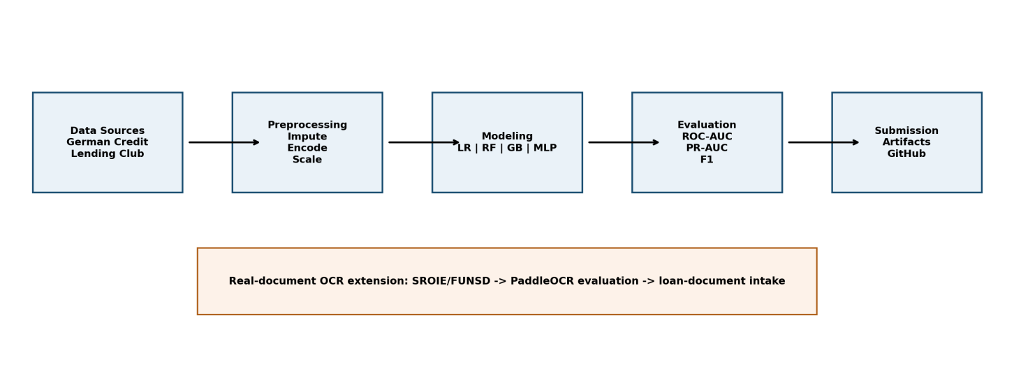
Figure 1: Overall project methodology and OCR extension.
Dataset | Use | Notes
German Credit | Credit-risk benchmark | Data set contains the UCI public datasets labeled with a binary risk label.
Lending Club Sample | Credit-risk benchmark | Sample of public records used for an evaluation created so that they can be used more effectively in testing.
ICDAR2019 SROIE | Real OCR preparation/evaluation | Each scanned image contains text, bounding boxes around the text, and different fields including: company, date, address, and total amount due.
FUNSD | Real OCR preparation/evaluation | Scanned forms were scanned with noise and marked with word level annotations to aid document comprehension.

TOOLS AND TECHNOLOGIES

Layer | Technologies
Programming | Python 3, modular package structure
Machine Learning | scikit-learn, pandas, NumPy
Visualization | matplotlib, saved ROC/PR/confusion/importance plots
OCR | PaddleOCR, SROIE/FUNSD conversion, recognition evaluation, and field-extraction design
Documentation | python-docx, python-pptx, Markdown, GitHub

IMPLEMENTATION
There are two areas of functional utility for the source code: Credit Scoring and Document OCR. The Credit Scoring runner reads in a JSON formatted benchmark suite, runs each model configuration, collects metrics, makes plots, and exports a CSV benchmark summary. The OCR runner converts scanned document annotations from real SROIE/FUNSD datasets into PaddleOCR recognized label sets, performs a baseline evaluation where PaddleOCR is available, and creates a CPU friendly fine-tuning configuration.

Module | Responsibility
credit_scoring.data | Loading dataset, sampling, exporting profile information, and summarizing class distribution.
credit_scoring.preprocessing | Utilities for imputing, encoding, scaling, and oversampling data.
credit_scoring.models | Model factory for different types of models (LR, RF, GB, MLP) with different configurations of parameters.
credit_scoring.evaluation | Generating metrics, curves, confusion matrix, and calculating feature importance.
document_ocr.real_data | Ingesting SROIE/FUNSD dataset, cropping text regions, generating PaddleOCR labels, and exporting manifest.
document_ocr.evaluation | Calculating character error rate (CER), proportion of words matched, exact-match rate, and exporting prediction samples from PaddleOCR.
document_ocr.real_pipeline | Orchestrate experimentation using real-life OCR to establish a baseline and facilitate optional tuning of experiments.

MAJOR FINDINGS / OUTCOMES / RESULTS
Dataset | Best Model | Strategy | ROC-AUC | PR-AUC | Recall | F1
German Credit | Logistic Regression | class_weight | 0.831 | 0.713 | 0.778 | 0.673
Lending Club Sample | Logistic Regression | class_weight | 0.722 | 0.360 | 0.682 | 0.430
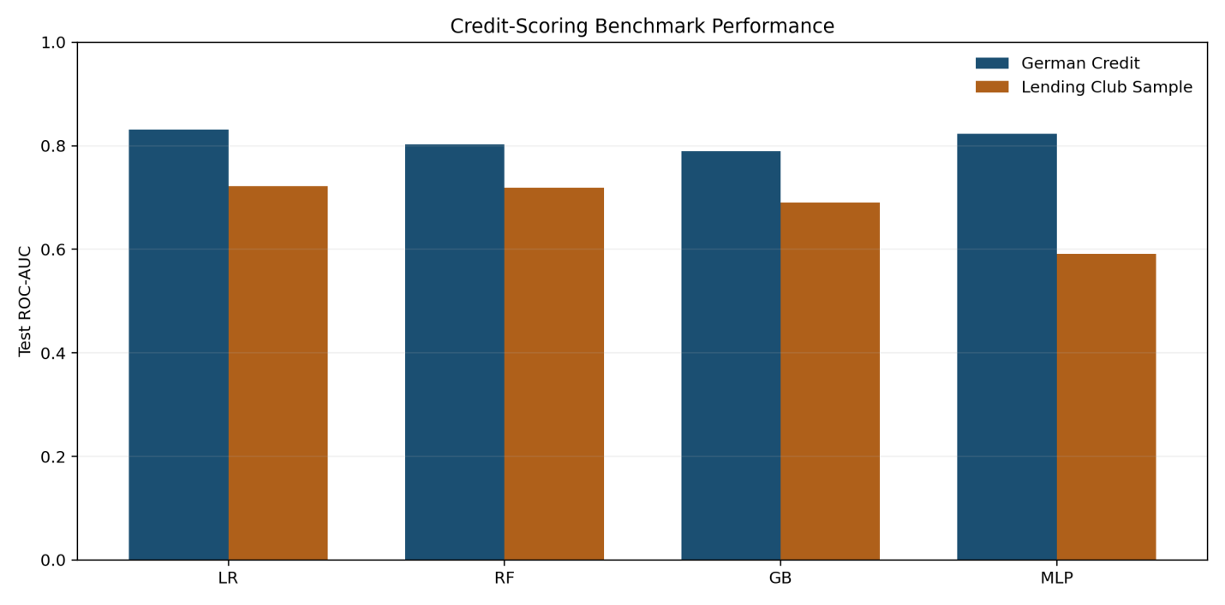
Figure 2: Credit-scoring benchmark comparison by model and dataset.

Class weights applied to Logistic Regression yield a good baseline for each public dataset that is intuitive and simple to use. This allows for both type one errors and type two errors to be evaluated on both data sets. The saved feature importance artifacts will also help in understanding the decision surfaces created by the model.
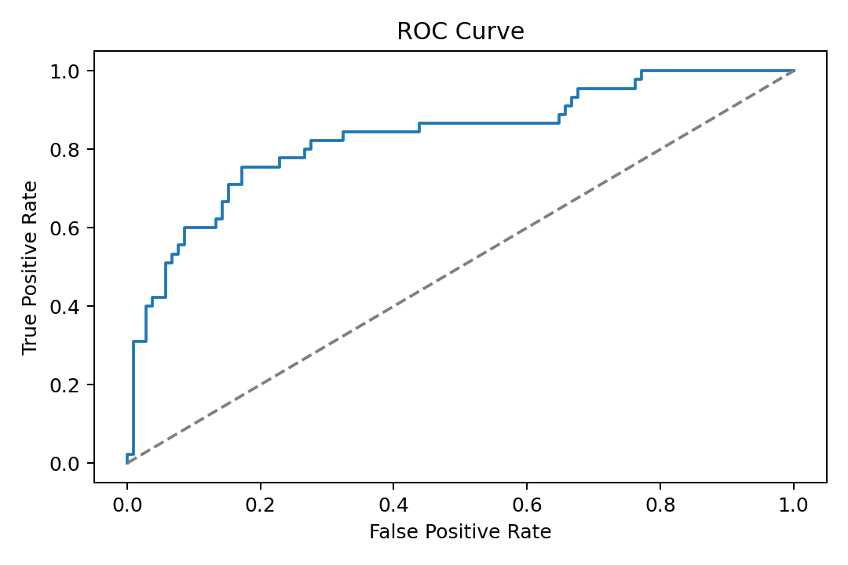
Figure 3: ROC curve for the best German Credit run.
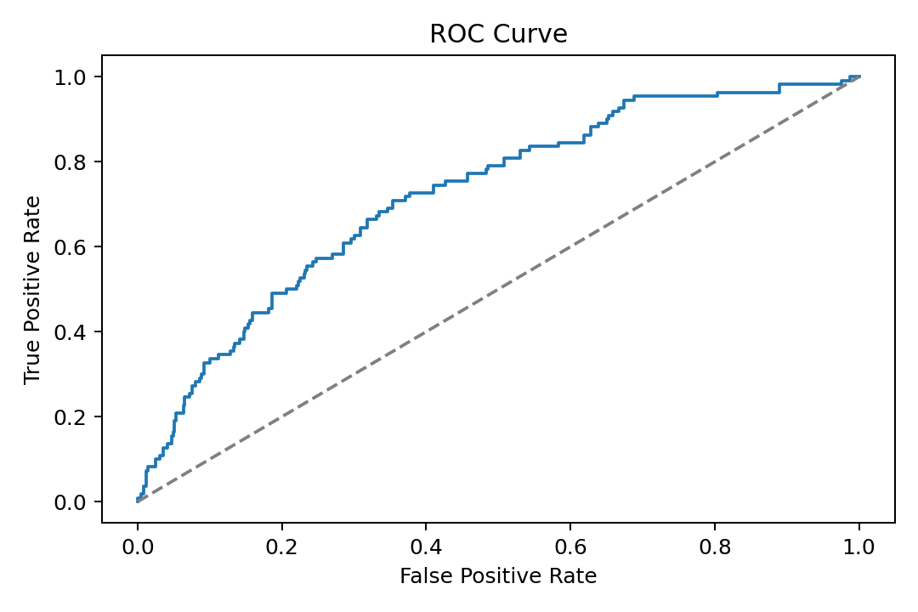
Figure 4: ROC curve for the best Lending Club sample run.
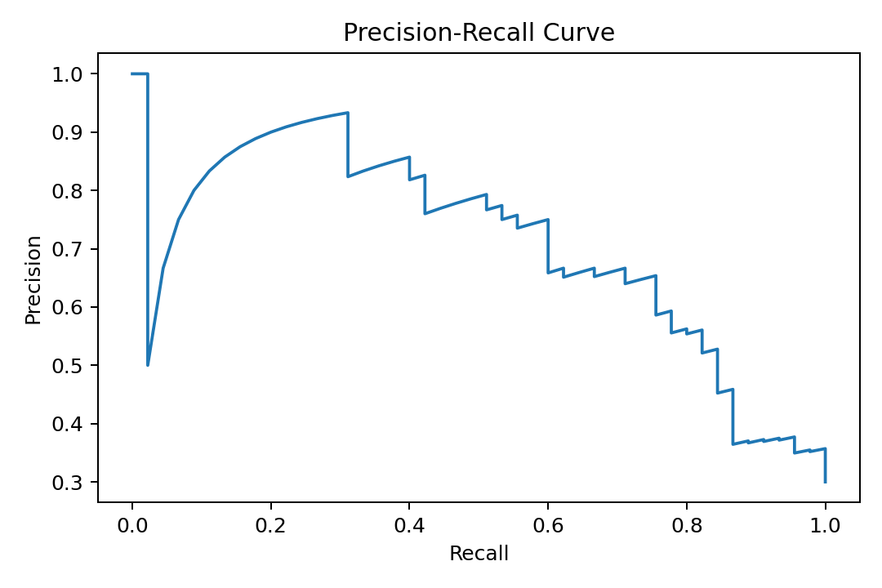
Figure 5: Precision-recall curve for the best German Credit run.
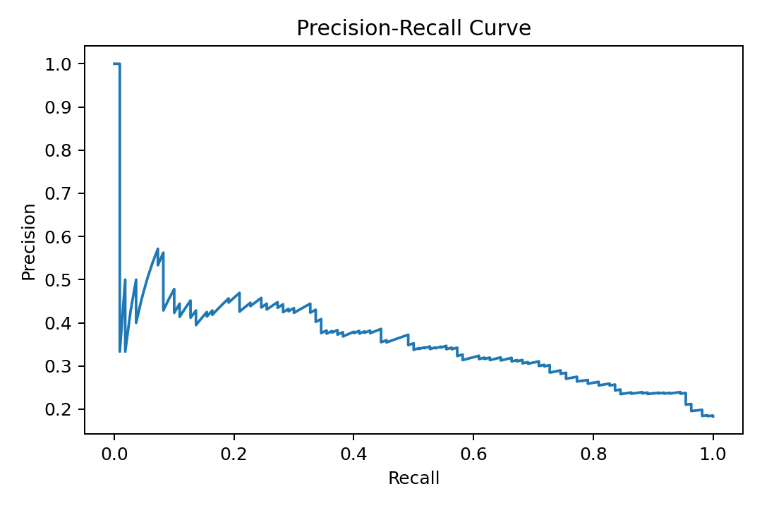
Figure 6: Precision-recall curve for the best Lending Club sample run.
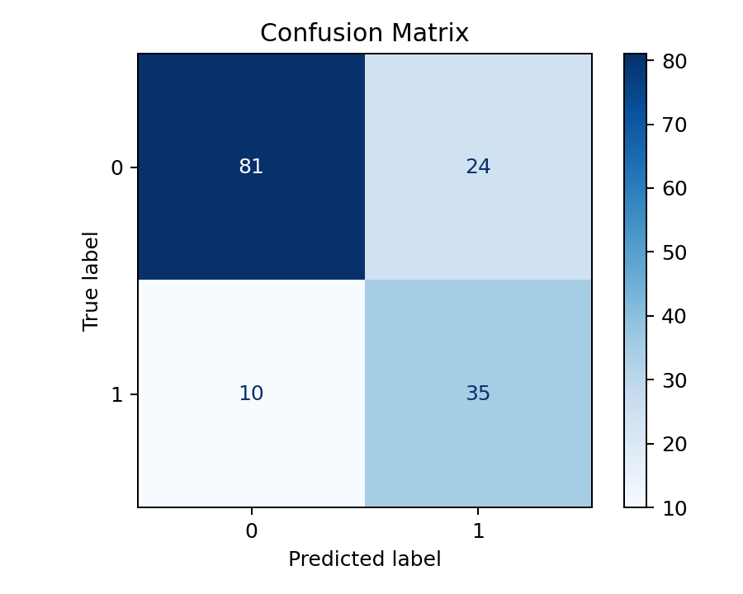
Figure 7: Confusion matrix for the best German Credit run.
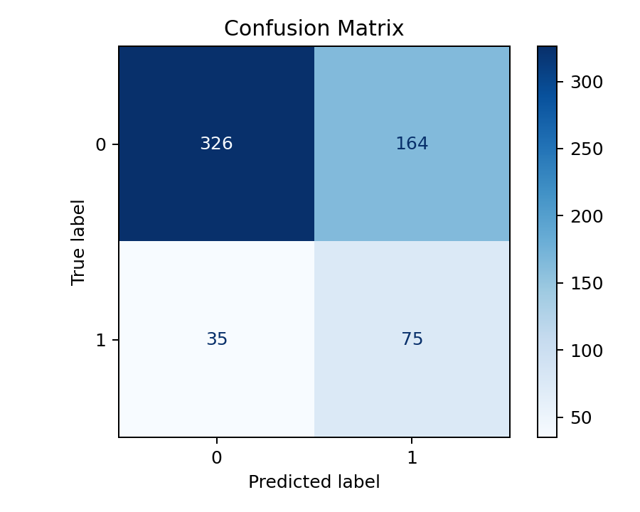
Figure 8: Confusion matrix for the best Lending Club sample run.
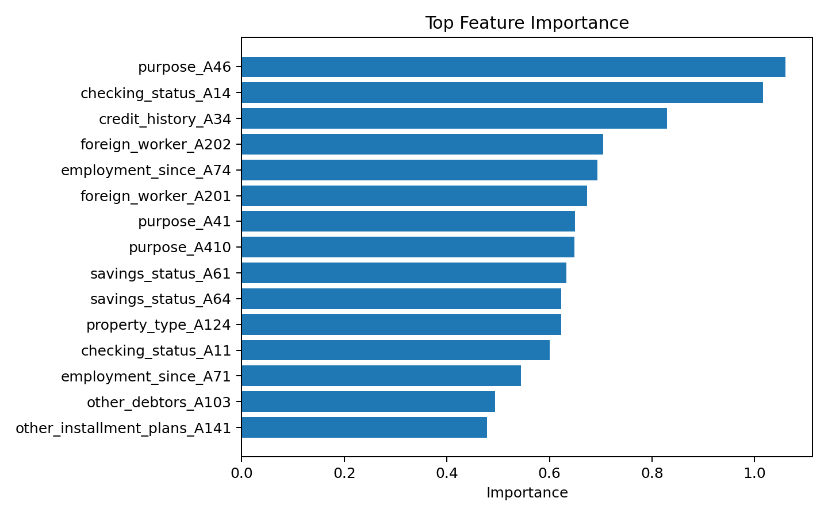
Figure 9: Top feature-importance output for the best German Credit run.
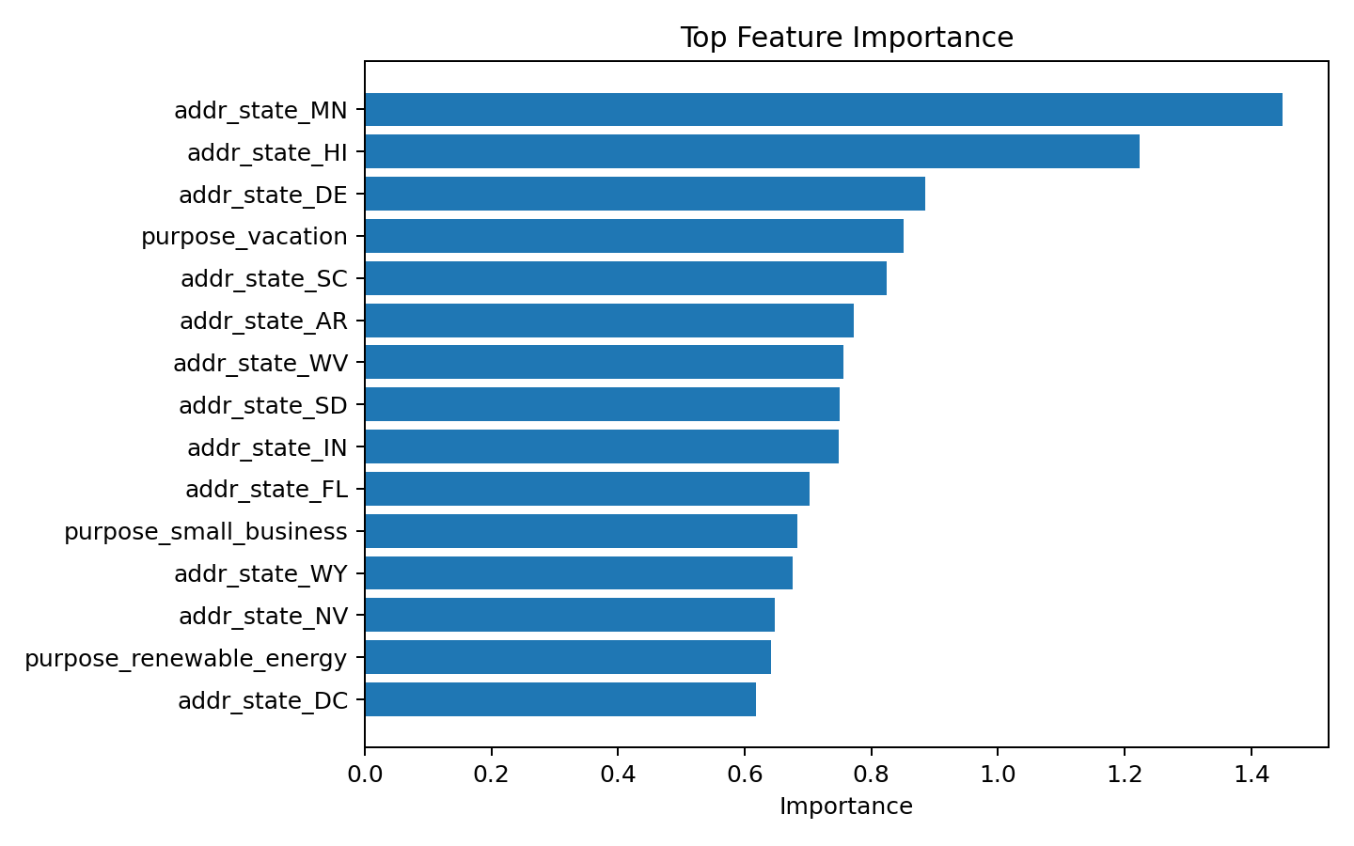
Figure 10: Top feature-importance output for the best Lending Club sample run.

OCR Module Implementation
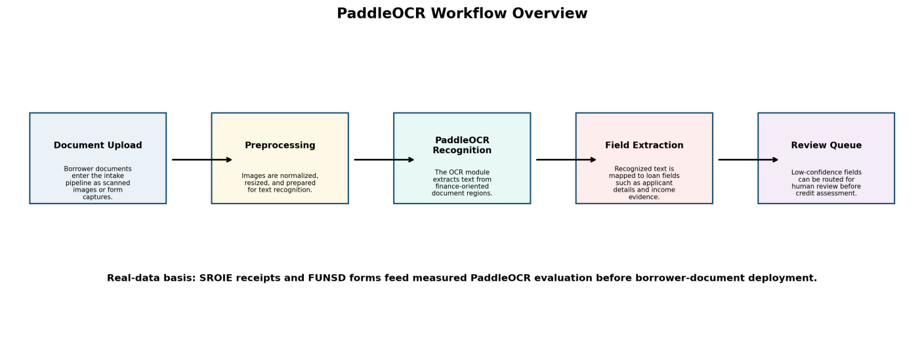
Figure 11: PaddleOCR workflow overview for borrower-document intake.
Workflow Stage | Implementation Purpose
Document Upload | Documents from borrowers are received into an intake pipeline where they are entered as both scanned images and/or form capture.
Preprocessing | The images are normalized, resized and processed for Optical character recognition.
PaddleOCR Recognition | The Optical character recognition (OCR) module extracts text from the areas of finance related to the document.
Field Extraction | The identified text is matched to various loan fields (e.g. Applicant Information, income verification).
Review Queue | Low confidence fields will be routed for Human review prior to the assessment of the credit.

Real SROIE/FUNSD OCR pipeline status: prepared_real_dataset. Prepared recognition crops: train:
1200, val: 300, test: 300.

Evaluation Run | Samples | CER | Word Accuracy | Exact Match
Pretrained PaddleOCR baseline | 25 | 0.110 | 0.691 | 0.440
The OCR component serves as a real data, document-intake workflow. The first measured OCR evidence layer is represented by scanned documents obtained from public sources. The deployment of borrower documents will occur after their privacy review, annotation, and held out validation.

5.2 Final Evaluation Readiness
Evaluation Area | Prepared Evidence
Submission / Filing Status | Created IPR proof Folder with Copyright Filing Instruction & Placeholder.
Target Platform Compliance | GitHub Repo Contains Required Folder Structure And Code Can Be Run.
Revision and Documentation | Final Report PPT, README, Figures, Template & Reproducible Generator Included.
Supervisor Meetings | Final Package Includes Progress Update Document & Feedback Handling Document.

The organization of the project package is based on the final evaluation components of filing readiness, GitHub platform compliance, documentation and revision handling, and supervisor progress evidence. The repository contains all of the components of the project including the README file, final project report, final project presentation, source code, templates, and IPR placeholder.

5.3 Supervisor Meetings and Feedback Handling
Progress Activity | Evidence in Submission
Regular progress updates | The final report captures the scope of the project, current status of its implementation, and reproduction of benchmark outputs.
Supervisor feedback handling | The revisions of the repository structure and final deliverable reflected the final evaluation directions.
Documentation updates | The README file and final project Report/PPT lay out how to access the folder structure, execute run commands, and how to access submission status.
External readiness | The GitHub repository contains the following contents: source code, report, PPT, IPR placeholder, and evaluation artifacts.

CONCLUSION AND FUTURE SCOPE

The final deliverable of the project is an AI-based loan-risk assessment tool that is reproducible and has clear benchmarks, traceable outputs, documents producing the results of explainability studies, and an OCR extension. The structure of the final GitHub configuration was set up in a way that will facilitate external evaluations by separating the IPR proof, report/PPT material, source code, and README documentation. Future improvements planned include conducting larger scale experiments with Lending Club, conducting calibration analysis, using SHAP-based explanations, conducting more thorough OCR assessment on scanned financial documents, and deploying the best model via an API or lightweight dashboard.

REFERENCES
- H. Hofmann, “UCI Machine Learning Repository,” archive.ics.uci.edu, Nov. 16, 1994. https://archive.ics.uci.edu/dataset/144/statlog+german+credit+data
‌
2.adgao, “GitHub - adgao/Kaggle_lending-club-loan: Kaggle dataset - Lending Club Loan Data - Credit Risk Modeling,” GitHub, 2025. https://github.com/adgao/Kaggle_lending-club-loan (accessed May 01, 2026).
‌3. “PaddlePaddle/PaddleOCR,” GitHub, Apr. 19, 2022. https://github.com/PaddlePaddle/PaddleOCR
4. “Dataset Card for Scanned Receipts OCR and Information Extraction — FiftyOne 1.14.2 documentation,” Voxel51.com, 2019. https://docs.voxel51.com/dataset_zoo/datasets_hf/scanned_receipts.html (accessed May 01, 2026).
5. “FUNSD,” guillaumejaume.github.io. https://guillaumejaume.github.io/FUNSD/
‌
6. GeeksforGeeks, “Scikit Learn Tutorial,” GeeksforGeeks, Jun. 26, 2025. https://www.geeksforgeeks.org/machine-learning/scikit-learn-tutorial/
7. R. Bahlool, N. Hewahi, and W. Elmedany, “Performance, Fairness, and Explainability in AI-Based Credit Scoring: A Systematic Literature Review,” Journal of Risk and Financial Management, vol. 19, no. 2, p. 104, Feb. 2026, doi: https://doi.org/10.3390/jrfm19020104.
‌

APPENDICES

Repository Folder | Contents
IPR Submission Proof | Proof of purchase and/or Copyright.
Report and PPT | Final deliverable include the final report, presentation(s), template(s), and generated figure(s).
Source code | All runnable Python code, configuration(s), test(s), sample(s), and other artifacts.
README.md | Team info (name, status, run command, evaluation instructions).

APPENDIX B: COPYRIGHT AND FORM XIV SUPPORT
Item | Prepared Detail
Project title | AI-Driven Credit Score Estimation System & OCR for Loan Risk Evaluation.
Project type | Copyright
Original material claimed | Team developed source-code, configuration, report, presentation, diagrams, workflow, and documentation related to the project.
Third-party material excluded | Paddle OCR & Paddle Paddle, public data sets, 3rd party libraries and pre-trained weights002E
Filing proof | Written acknowledgement and print-out will be attached as soon as formal application is made.

